- Why is software testing essential in the software development life cycle? Describe how software testing is carried out, and explain various types of testing approaches with examples, based on different needs and purposes.

Software Testing in SDLC with Java and Room Rent System

Introduction
Software testing is a systematic process of evaluating software to identify defects and verify whether it satisfies specified requirements.
For example, consider a Room Rent Management System developed using Java. The system may allow:
- Tenant registration
- Room management
- Room allocation
- Rent calculation
- Rent payment
- Complaint management
- Payment history
- Admin management
Testing ensures that these functions work correctly and reliably.

1. Why is Software Testing Essential?

1. Detects defects
Testing identifies mistakes in Java code.
Example:
Suppose the rent should be:
totalRent = monthlyRent * months;
But the developer writes:
totalRent = monthlyRent + months;
Testing can identify this defect.

2. Ensures requirements are satisfied
Testing verifies that the software performs according to the requirements.
Example:
Requirement:
"A tenant should be able to pay monthly room rent."
Test whether the Java application successfully records the tenant's payment.

3. Reduces risk
Testing detects problems before the system is delivered to tenants and landlords.

4. Reduces maintenance cost
Finding an error during development is generally easier than discovering it after the system is deployed.

5. Improves software quality
Testing improves:
- Reliability
- Performance
- Security
- Usability
- Maintainability

2. How Software Testing is Carried Out
Consider a Java-based Room Rent Management System.

Step 1: Test Planning
The team decides what must be tested.
For example:
- Room Registration
- Room Allocation
- Rent Calculation
- Rent Payment
Tenant Management

Step 2: Test Case Design
Test cases are prepared.

Example: Rent Calculation
Monthly Rent | Months | Expected Result
Rs. 10,000 | 1 | Rs. 10,000
Rs. 10,000 | 3 | Rs. 30,000
Rs. 15,000 | 6 | Rs. 90,000

Step 3: Test Environment
Prepare:
- Java/JDK
- Database
- Application server
- Test database
- Test data
For example:
Java + Spring Boot + PostgreSQL

Step 4: Test Execution
Execute the test cases.
Suppose:
- Expected rent = Rs. 30,000
Actual rent = Rs. 20,000
Since:
Expected ≠ Actual → Defect

Step 5: Defect Reporting
The tester reports:
- Defect: Incorrect rent calculation
- Expected: Rs. 30,000
- Actual: Rs. 20,000
Severity: High

Step 6: Debugging
The Java developer investigates and corrects the code.
- public double calculateRent(double monthlyRent, int months) {
- return monthlyRent * months;
}

Step 7: Retesting
The same test case is executed again.
- Rs. 10,000 × 3
= Rs. 30,000 ✓

Step 8: Regression Testing
After fixing rent calculation, testers ensure that other functions such as payment, invoice generation, and tenant records still work.

3. Types of Testing

A. Testing Based on Level
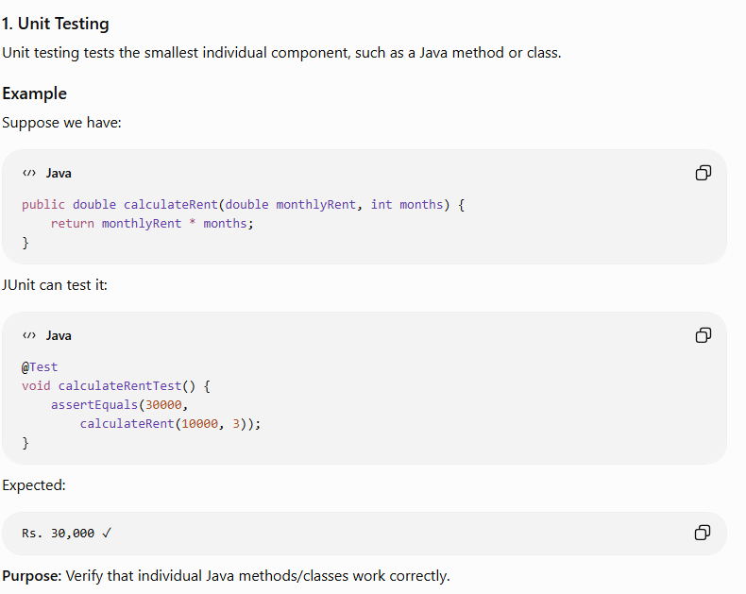

2. Integration Testing
Integration testing checks whether multiple components work correctly together.
For the Room Rent System:
- Tenant
- ↓
- Rent Service
- ↓
- Payment Service
- ↓
PostgreSQL Database

Example
A tenant pays Rs. 10,000.
The system should:
- Payment Service
- ↓
- Save Payment
- ↓
- Update Rent Status
- ↓
Generate Receipt
Integration testing verifies that these components communicate correctly.

3. System Testing
System testing tests the complete Room Rent Management System.
Example:
- Login
- ↓
- Register Tenant
- ↓
- View Available Room
- ↓
- Allocate Room
- ↓
- Calculate Rent
- ↓
- Pay Rent
- ↓
Generate Receipt
The complete workflow is tested as one system.

4. Acceptance Testing
Acceptance testing determines whether the system satisfies the actual customer's requirements.

Example
The landlord tests whether:
- New rooms can be added
- Tenants can be registered
- Rooms can be allocated
- Rent can be calculated
- Payments can be recorded
- Reports can be generated
If the system satisfies the agreed requirements, the customer can accept it.

4. Testing Based on Technique

1. Black-Box Testing
The tester does not need to know the internal Java code.
The tester provides input and checks the output.

Example: Room Rent
Suppose monthly rent must be between:
Rs. 5,000 – Rs. 50,000
Test:
Input | Expected
Rs. 4,999 | Invalid
Rs. 5,000 | Valid
Rs. 20,000 | Valid
Rs. 50,000 | Valid
Rs. 50,001 | Invalid
This is Boundary Value Analysis.

2. White-Box Testing
Here the tester knows the internal Java code.

Example
- if (rentPaid >= monthlyRent) {
- status = "PAID";
- } else {
- status = "PENDING";
}
Tests should cover both branches:
- rentPaid >= monthlyRent
- ↓
- PAID

- rentPaid < monthlyRent
- ↓
PENDING
This tests the internal decision logic.

5. Testing Based on Purpose

1. Regression Testing
Regression testing checks whether a modification has broken existing functionality.

Example
Suppose the developer modifies the rent payment module.
After modification, we should test:
- Login ✓
- Tenant Registration ✓
- Room Allocation ✓
- Rent Calculation ✓
- Rent Payment ✓
Receipt Generation ✓
Even though only payment was modified, other related functions must be checked.

2. Smoke Testing
Smoke testing is a quick basic test performed on a new Java build.
Example:
- Application starts ✓
- Login works ✓
- Database connection ✓
- Room list loads ✓
Tenant page opens ✓
If the application cannot even start or connect to the database, detailed testing should not continue.

3. Stress Testing
Stress testing checks the system under extreme conditions.

Example
Suppose the Room Rent System normally supports:
500 tenants
Test the system with:
- 1,000
- 2,000
5,000
simultaneous users.
The objective is to determine when performance becomes unacceptable or the system fails.

4. Performance Testing
Performance testing measures the speed and resource usage of the system.

Example
Suppose 500 tenants simultaneously open the rent-payment page.
Test:
- Response Time
- CPU Usage
- Memory Usage
- Database Response
Number of Requests/Second
The objective is to ensure the Java application remains responsive.

5. Security Testing
Security testing verifies that unauthorized users cannot access protected information.

Example
A tenant should only be able to see their own rent history.
- Tenant A → Tenant A's payment history ✓
Tenant A → Tenant B's payment history ✗
Other security tests can verify:
- Login authentication
- Password protection
- Authorization
- Session management
- SQL injection protection

6. Alpha Testing
Alpha testing is generally performed by the development organization before releasing the software to external users.

Example
The developers and internal testers test the Room Rent System before giving it to the landlord.

7. Beta Testing
Beta testing is performed by selected real users in a realistic environment.

Example
The Room Rent System is provided to:
- 5 Landlords
20 Tenants
They use the system and report real-world problems before the final release.

6. Complete Example
Suppose we have this Java method:
- public double calculateRent(double rent, int months) {
- return rent * months;
}
Different testing approaches can test it differently:
Testing | How it tests calculateRent()
Unit | Tests the Java method individually
Integration | Tests Rent Service + Database
System | Tests complete rent-payment process
Acceptance | Checks whether landlord's rent requirements are satisfied
Black-box | Gives rent/month values and checks output
White-box | Examines Java logic and execution paths
Regression | Checks calculation after code modification
Performance | Tests many rent calculations simultaneously

7. Easy Diagram for Exam
- SOFTWARE TESTING
- │
- ┌──────────────┼──────────────┐
- ↓ ↓ ↓
- LEVEL TECHNIQUE PURPOSE
- │ │ │
- Unit Testing Black-box Regression
- │ White-box Smoke
- Integration Stress
- │ Performance
- System Security
- │ Alpha
Acceptance Beta

Easy Memory Technique
For Room Rent System, remember:

"UISA – BW – RSSPSAB"
U → Unit
I → Integration
S → System
A → Acceptance
B → Black-box
W → White-box
R → Regression
S → Smoke
S → Stress
P → Performance
S → Security
A → Alpha
B → Beta

One-line conclusion for the exam
In a Java-based Room Rent Management System, software testing systematically verifies individual Java components, their integration, the complete system, and user requirements while using different techniques such as black-box, white-box, regression, performance, and security testing to ensure a reliable, secure, and high-quality system.

